EE103 Midterm Examination November 1, 2017
Name______________________ ID______________________
[1]. (20 pts) For x(t) = (1- t) u(t -1), where u(t) = 1 for t$≥0$, and 0 for t<0.
(a). Draw its even and odd functions, xe(t) and xo(t).
(b). Add the even and odd functions to show that x(t)= xe(t) + xo(t).

[2].(30 pts) Consider a system with its x(t) to y(t) relationship characterized by h(t).
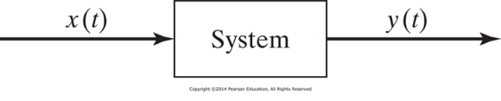
(a). (15 points) When h(t) = exp(-2t) u(t) and x(t) = 2[u(t) - u(t-2)], find mathematical expression of y(t) by using a convolution integral for t = 0 to 2.

(b). (15 pts) Let H(ω) = 2/(4+jω), where ω = 2$π$f, find y(t) for x(t) = 2cos3t. You can express y(t) as a sinusoidal function with a phase angle in the form of arctan (a/b) with numerical values of a and b.

(30 pts) Consider the RC circuit shown below.
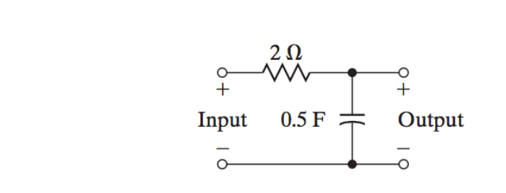
(a).(15 pts) Write down a differential equation to describe the input-output relationship by using x(t) for input and y(t) for output.

(b).(15pts) Find y(t) for zero initial condition and x(t)=u(t).(Hint: Laplace transform (LT) method would be handy. LT of dy(t)/dt = sY(s), LT of constant K = K/s, Inverse LT of A/(s+B) is Aexp(-Bt))

(4). (20 pts) A multiplexed signal s(t) is a product of two cos functions, f(t)=2cos(100t)
and g(t)= 5 cos(500t). Find the frequency spectrum of s(t) and plot the magnitude and phase angle information on the graphs below.

